1. Agenda:
   1. How to remove a container automatically rather than manually with command docker rm <container-id>
2. 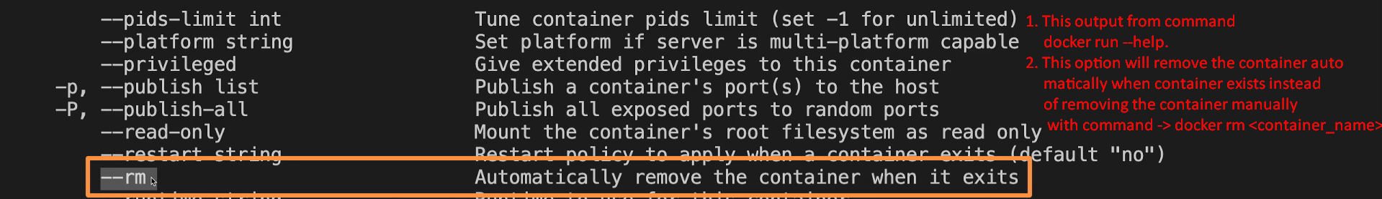
3. 